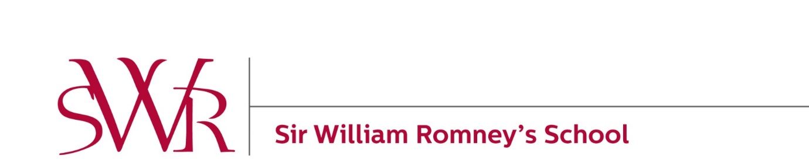

Sir William Romney’s School
Equality Objectives

Objective 1
By the end of the 2020/21 school year boys’ GCSE outcomes will be in-line with expectations and will continue to improve year on year.
Why we have chosen this objective:
- Whereas girls achieved a Progress 8 score of +0.17 in their GCSE outcomes in 2017, boys’ Progress 8 score was -0.14 (still above the national benchmark of -0.24 for boys).
- English outcomes in 2017 also followed a similar pattern with girls (+0.37) making better progress than boys (-0.3) but with boys performing better than national benchmarks.
- However, in 2017, it must also be noted that boys (+0.19) performed better than girls (-0.24) in Mathematics.
- While boys’ GCSE achievement improved in 2018 with a Progress 8 score of -0.09 (significantly above national benchmarks), the gap with girls was still significant.

To achieve this objective we plan to:
- Review our curriculum to identify opportunities to inspire boys to realise their full potential
- Undertake student voice and student pursuits with a wide cross-section of boys to understand and subsequently remove identified barriers to learning
- Explore extra-curricular activities and careers advice that promotes male achievement and success.

Progress we are making towards this objective:
- Senior Leader strategic discussions that focus on addressing the achievement gap.

Objective 2
By the end of the 2019/20 academic year, provide facilities and equality of opportunity for Transgender students and staff that reflect our inclusive ethos.

Why we have chosen this objective:
The Equality Act 2010 requires schools to not treat students less favourably due to the protected characteristic of gender reassignment. The Equality Act also protects those who are discriminated against because they are perceived to be trans or discriminated against because of their association with a trans person.

SWR is fully inclusive and embraces a whole school approach that provides a space where young people are able to come out as trans and or transition. Therefore, we welcome children and young people who are at various stages of exploring their identities or transitioning. This includes but isn’t limited to those who are just coming out as trans, those who have socially transitioned either partly or fully and those who are exploring their gender identity with no fixed pathway.

To achieve this objective we plan to:
- Ensure trans issues and transphobia are acknowledged across the policy framework and as one part of the settings approach to equality and inclusion
- Acknowledge there are or will be trans people within the educational setting and that this diversity is welcomed
- Ensure that the curriculum and in particular PSHE education and work related to spiritual, moral, social and cultural development is used to challenge gender stereotypes, support the development of gender equality, a positive understanding of gender identity and prevent sexism and transphobia
- Closely monitor all areas of the curriculum, resources and teaching and learning approaches to ensure trans inclusive practice that challenges gender stereotypes
- Effectively challenge, record and deal with transphobic abuse, harassment

Progress we are making towards this objective:
- A Transgender Practice Statement distributed to all staff and governors in December 2018 outlining our commitment towards developing an inclusive school for trans students and staff.
- The Headteacher has led assemblies to all year groups raising awareness of trans and transgender students and outlined how the school will support students who identify as trans.
- A unisex toilet has been introduced in January 2018.
- Transgender students will always be referred to by their preferred name and pronoun.
- Transgender students are allowed to wear their preferred gender appropriate uniform and PE kit.

Objective 3
Train all members of staff and governors involved in recruitment and selection on equal opportunities and non-discrimination by the beginning of the next academic year. Training evaluation data will show that 100% of those attending have a good understanding of the legal requirements.

Why we have chosen this objective:
To ensure that all leaders and governors involved in recruitment and selection understand their statutory responsibilities and that all interviews consistently ensure equality of opportunity.

To achieve this objective we plan to:
- Provide training for senior leaders, operational managers and identified governors on equal opportunity legislation for recruitment
- Require all leaders and governors to audit their understanding of equal opportunities legislation for recruitment and selection purposes
- Review all decisions made by recruitment and selection panels to ensure consistency

Progress we are making towards this objective:

